DTCC in Insurance Sector

Overview:

Depository Trust and Clearing Corporation (DTCC) was established in 1999 as a holding company to combine Depository Trust Corporation (DTC) and National Securities Clearing Corporation (NSCC). Its primary business is to provide an efficient and safe way for buyers and sellers of securities to make their exchange, and thus "clear and settle" transactions. It also provides custody of securities. DTCC provides clearance, settlement, and information services for the financial sector. It is also playing a leading role as processor of mutual funds, insurance transactions, linking funds and carriers with their distribution network.

In late 1960s and early 1970s the brokers were still using paper certificates and checks for each trade where 10 to 12 million share were handled daily. Huge volumes of paper were moved daily, leading to a paper work crisis. The crisis became so severe that, to reduce backlog the exchanges started closing on every Wednesday and shortened trading hours on the other days and extended the settlement from T+4 to T+5 days.

To resolve the paperwork problem the industry developed two separate and distinct approaches.

- Immobilization: The first solution was to avoid movement of physical stocks. The stocks would be maintained in one location or depository and changes of ownership would be recorded using “book entry” accounting methods where no certificates will actually change hands. This is the function of DTC. In 2006, DTC settled transactions worth almost $445 trillion, and processed 292.7 million book-entry deliveries

- Netting: The second solution was based on the concept multilateral netting. When a broker sells and buys the same script in the market there is an opportunity for netting by introducing a common counter-party to all trades. By this all the trades by a single broker will lead only to one net position and the settlement can be done by a single money transfer between the broker and the common counter-party. This is the function of NSCC. NSCC now generally clears and settles in T+3 days.

Among the subsidiaries of DTCC, NSCC provides several services that are widely used by various Insurance carrier’s and distributors.
The services provided by NSCC in Insurance Sector:

- Applications (APP) & Subsequent Premiums (SUB): Using this Service the distributors can transfer the Applications (APP) & Subsequent Premiums (SUB) information to the carriers. This service provides an efficient, straight-through process for validating, formatting, and submitting annuity applications and subsequent premium payments. It enables same-day money settlement. By using this service the turnaround time for issuing annuity contracts has been reduced. It simplifies and streamlines the sales process by reducing paper and manual work.

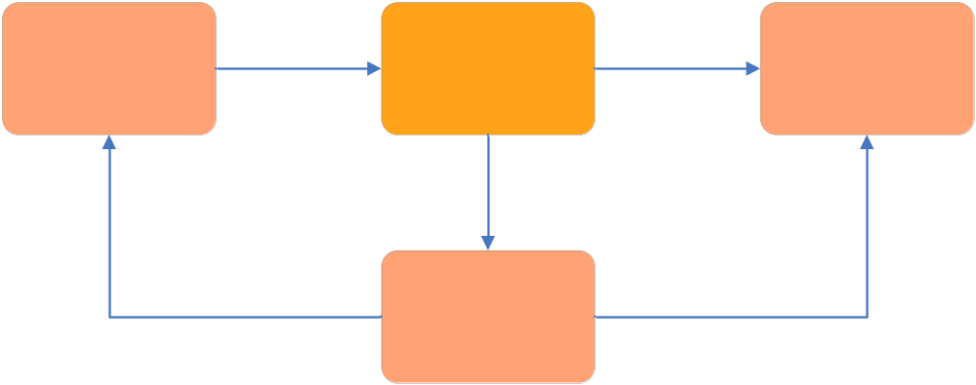

- Asset Pricing (AAP): This enables insurance carriers to send the unit values for underlying funds within variable annuity and life insurance products to distributors on a daily basis. Unit values are similar to net asset values of mutual funds.

- Commissions (COM): This enables transferring of information about commissions and compensation details from the carriers to distributors for annuities and life insurance products sales. This reduces the turnaround time for paying commissions. This enables automation of commission payments and payments on daily basis.

- Financial Activity Reporting (FAR): This enables insurance carriers to provide distributors with daily annuity and life insurance financial transaction information. Using this distributor can get comprehensive and accurate picture of client accounts. It also provides comprehensive account statements to distributors.

- Licensing & Appointments (L&A): This automates and standardizes the two-way flow of information needed to manage agent information between insurance carriers and distributors, eliminating paper and simplifying data exchange. It also provides for money settlement between parties for licensing- and appointment-related fees. This enables reduction of operating costs, reduction of lead-time for obtaining licensing and appointment authorization, execute mass appointments and transfer appointments from one distributor to another.

- LNA Access: This is a non-integrated / standalone online data entry request and confirmation reporting tool that allows distributors to enter pre-defined required data for appointment requests and appointment terminations, producer terminations, address changes, rep ID number changes and license confirmations.
- In-force Transactions (IFT): This is a service that facilitates the exchange of information between insurance carriers and distributors for broker/dealer changes via ACATS/IPS, as well as Registered Representative and Broker Identification Number (BIN) changes that occur outside of Automated Customer Account Transfer Service (ACATS). IFT provides an automated method of sending, receiving and tracking change instructions. Reports on the status of changes are automatically delivered to carriers and distributors.

- Fund Transfers (FTR): This enables Distributors and Insurance Carriers to perform their fund transfer transactions in real-time. It is comprised of two distinct transactions:
  - Values Inquiry enables Distributors to request and receive from Carriers the most current contract information prior to submitting a fund transfer request.
  - Fund Transfers automates a direct exchange or one-time reallocation of the underlying funds within a variable insurance asset. This request includes modifications to the service features affected by the exchange.

- Positions & Valuations (POV): This enables insurance carriers to send annuity and life insurance contract details to distributors on a daily, weekly, monthly, or other periodic basis, giving them a current snapshot of their entire book of business.

Data are available in three formats:

A focused refresh file (PFF), including underlying fund and current value information. A PFF file includes the distributor's entire book of business and is typically sent on a daily basis.

A full refresh file (PVF) that provides PFF data, as well as information pertaining to contract parties and service features. A PVF file includes the distributor's entire book of business, transmitted periodically according to a schedule agreed upon by trading partners.

A new business file (PNF) that provides data identical to the PVF file but includes only new contract information. A PNF file contains information on contracts that are newly issued or have a change of agent with a new broker-dealer affiliation. The file is sent once each day; after that, the contract information is included in PFF or PVF files

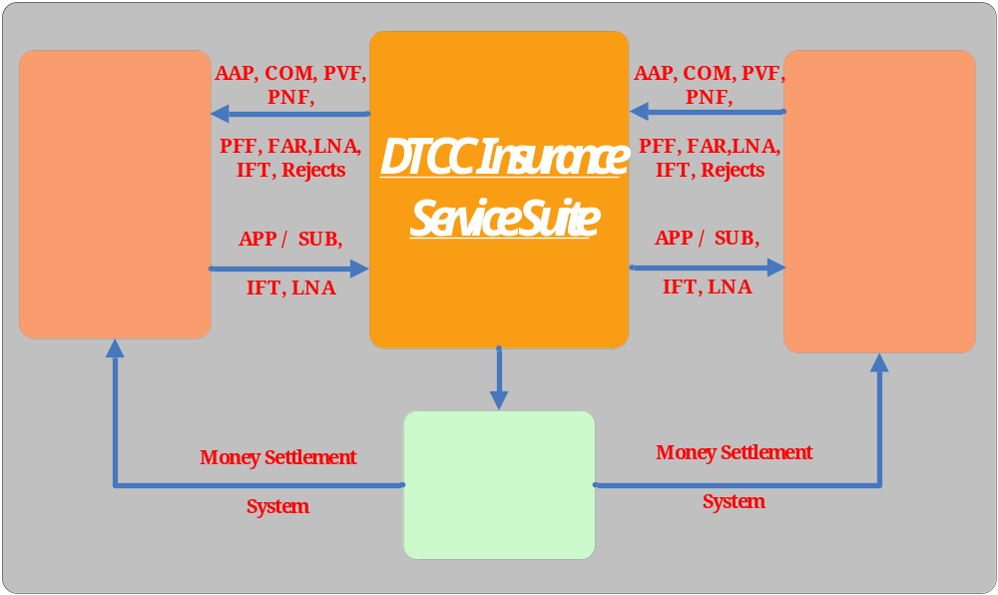
Data flow diagram for APP/SUB, AAP, FAR, POV, IFT, LNA

- ACATS/IPS: This automates the change in broker/dealer of record for an annuity when clients move their accounts from one brokerage firm to another. The service also facilitates broker-of-record and broker identification number changes within a firm. ACATS/IPS enables distributors to include annuity assets, along with other securities, when transferring accounts and gives them automated, timely access to important information about their customers' portfolios.

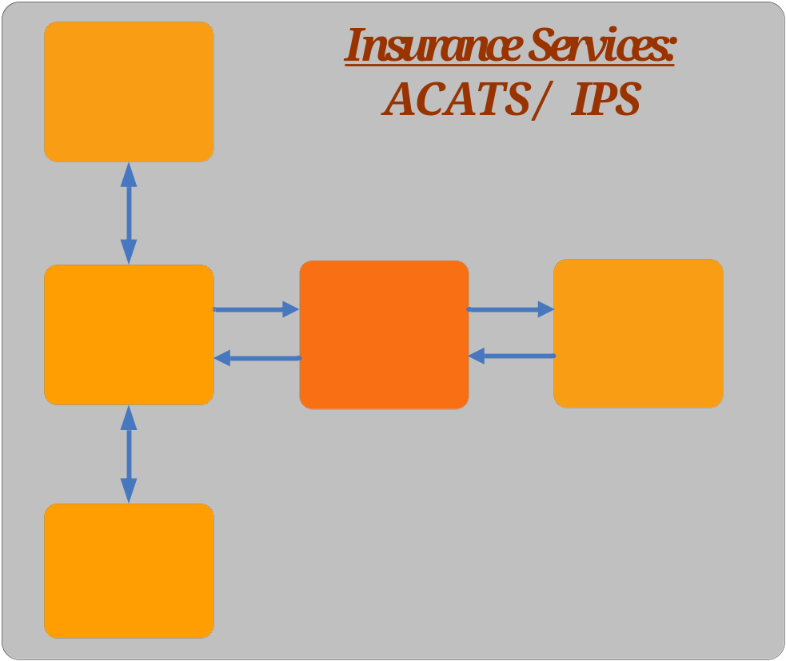

- Participant Information and Efficiency Report (P.I.E.R.): This provides a monthly summary of a firm’s DTCC utilization activity, including Insurance Services information beginning January 2008. This report displays the firm’s trading relationships and transactional volume activity totals by product. For products having a money settlement component, the report includes the firm’s gross settlement amount for a given month.

IBM is helping its clients in connecting their Policy Administration systems to DTCC. The scope of the project is:
- Designing the strategy on how the policy admin and DTCC to be linked both in Data and technology perspective.
- Building the middleware to connect Policy Administration system and DTCC.
- End to end testing including Unit, integration, system and enterprise testing.

Enrollment with NSCC is a mandatory requirement for Insurance carriers in US if the insurer is dealing with market linked funds.

Volumes and Value Handled by DTCC in the 2007:

Settlement
- Value of securities settled through DTCC $1.86 quadrillion
- Value of money market settlement activity $154.5 trillion
- Value of securities on deposit at DTC $40.1 trillion
- Volume of non-U.S. issues on deposit $7.6 trillion
- Volume of book-entry deliveries 324.9 million

Equity, ETF, corporate and municipal bond transactions processed (NSCC)
- Value and Volume of NSCC equity, municipal/corporate bond and ETF transactions processed $283.2 trillion and 13.5 billion respectively.
- Volume on peak day (NSCC- 8/16/07) 98.5 million
- Peak day netting factor 99%

Insurance applications, premiums and commissions processed (NSCC)
- Value : $20.8 billion
- Volume : 63.1 million

Some of the other clearing organizations around the world are:

Europe:
ClearnetSBFSA, Paris
Eurex Clearing AG, Frankfurt
London Clearing House (LCH)

Asia:
Hong Kong Exchanges and Clearing Limited (HKEx)
Singapore Exchange Limited (SGX)
Tokyo Stock Exchange (TSE)

America:
The Brazilian Clearing and Depository Corporation (CBLC),
The Canadian Depository for Securities Limited (CDS), Toronto, Ontario
The Depository Trust & Clearing Corporation, New York
The Options Clearing Corporation (OCC), Chicago, Illinois

By Sathish Kumar

